**IA-1**

**INFORMATION SECURITY**

**SECURITY TOOL: NESSUS**

**REPORT**

**Roll no: (16010122222)**

**(16010122236)**

**(16010122245)**

**(16010122248)**

**Introduction:**

Nessus is a platform developed by Tenable that scans for security vulnerabilities in devices, applications, operating systems, cloud services, and other network resources. It is a widely used vulnerability scanning tool in the field of cyber security and security testing. It is a remote security scanning tool, which scans a computer and raises an alert if it discovers any vulnerabilities that malicious hackers could use to gain access to any computer, that you have connected with any network. It does this by running over 1200 checks on a given computer, to see if any of these attacks could be used to break into the computer or otherwise harm it.

**Features:**

**1. Comprehensive Vulnerability Assessment**

Nessus conducts in-depth scans across systems, networks, and applications, detecting known vulnerabilities, misconfigurations, default credentials, and insecure protocols. Its extensive library of vulnerability checks ensures a detailed security analysis, helping organizations identify and mitigate risks before exploitation.

**2. Broad Platform Coverage**

Nessus supports a wide range of platforms, including operating systems, databases, web applications, and network devices. This flexibility allows organizations to secure their entire IT infrastructure from potential threats, making it a versatile security tool.

**3. Continuous Updates for Emerging Threats**

The tool's vulnerability database is frequently updated to stay ahead of evolving cyber threats. It integrates the latest CVE data, security advisories, and compliance checks, ensuring organizations have access to the most up-to-date security insights.

**4. Risk-Based Prioritization and Reporting**

Nessus assigns risk ratings (Critical, High, Medium, Low) using CVSS scores, enabling businesses to prioritize remediation efforts efficiently. Detailed, customizable reports provide actionable insights, helping teams streamline vulnerability management.

**5. Agent-Based and Agentless Scanning**

Nessus offers both agent-based and agentless scanning options. Agent-based scanning continuously monitors endpoints, even offline, while agentless scanning provides quick network-wide assessments without requiring software installation on individual devices.

**Methodology**

**1. Pre-Assessment Phase**

**a) Defining the Scope**

Before initiating a scan, it is essential to define the scope, including:

* **Target Systems**: Decide which assets (servers, endpoints, cloud environments, etc.) will be scanned.
* **Network Range**: Define the IP range or domain names of systems to be assessed.
* **Scanning Type**: Determine whether to conduct **external scans** (to detect internet-facing vulnerabilities) or **internal scans** (to identify local security issues).
* **Compliance Requirements**: Align the assessment with **industry standards** (PCI-DSS, HIPAA, NIST, etc.).

**b) Setting Up Nessus**

* Download and install **Nessus Essentials (free)** or **Nessus Professional (paid)** based on requirements.
* Configure **Nessus Scanner** on a dedicated machine with proper network access.
* Update Nessus plugins and vulnerability database to ensure **latest threat detection**.

**c) Credential Management**

* Use **authenticated scans** (where credentials are provided) for deeper assessments.
* Store and encrypt credentials securely within Nessus to prevent leakage.

**2. Active Scanning Phase**

**a) Choosing Scan Policies**

Nessus provides pre-built scanning templates based on the objective, such as:

* **Basic Network Scan** (General vulnerability detection).
* **Advanced Scan** (Custom configuration for in-depth analysis).
* **Malware Scan** (Detects signs of malware infections).
* **Configuration Audits** (Checks compliance against security standards).

**b) Configuring Scan Settings**

* Select the **scan type**: Full scan, partial scan, or targeted scan.
* Define **network throttling options** to prevent bandwidth overload.
* Configure **scan schedules** for automation and periodic assessments.

**c) Executing the Scan**

* Run the scan with the configured parameters.
* Nessus will perform **port scanning, service enumeration, and vulnerability checks**.
* The scanner will identify **misconfigurations, outdated software, weak credentials, and exploitable vulnerabilities**.

**3. Post-Assessment Phase**

**a) Analyzing Scan Results**

* Review the **Nessus report** which categorizes vulnerabilities into:
  + **Critical** (immediate threats like RCE, privilege escalation).
  + **High** (major security flaws, exploits available).
  + **Medium** (configuration issues, exposed services).
  + **Low** (minor security risks).
* Identify the **Common Vulnerabilities and Exposures (CVE) IDs** associated with detected threats.

**b) Risk Prioritization**

* Prioritize vulnerabilities based on **risk impact and exploitability**.
* Use the **CVSS (Common Vulnerability Scoring System) score** to determine severity.
* Focus on vulnerabilities that have **public exploits** or **pose immediate risks** to business operations.

**c) Remediation & Mitigation**

* **Patch Management**: Update outdated software, apply security patches.
* **Configuration Hardening**: Disable unnecessary services, enforce secure settings.
* **Access Control**: Implement **strong authentication and least privilege access**.
* **Network Security Measures**: Use **firewalls, intrusion prevention systems (IPS), and network segmentation** to mitigate risks.

**4. Continuous Monitoring & Compliance**

**a) Scheduling Regular Scans**

* Automate **weekly/monthly Nessus scans** to track new vulnerabilities.
* Configure **real-time alerts** for critical vulnerabilities.

**b) Compliance Auditing**

* Use Nessus for **regulatory compliance checks** (PCI-DSS, HIPAA, ISO 27001).
* Generate compliance reports to ensure **organizations meet security requirements**.

**c) Integrating Nessus with SIEM & Security Operations**

* Integrate Nessus with **Security Information and Event Management (SIEM)** tools for **real-time monitoring**.
* Combine scan results with **Intrusion Detection Systems (IDS) and Threat Intelligence** for proactive defense.

**5. Reporting & Documentation**

**a) Generating Reports**

* Export Nessus reports in **PDF, CSV, or HTML format**.
* Customize reports for **technical teams (detailed vulnerability analysis)** or **management (high-level security overview)**.

**b) Incident Response & Patch Verification**

* Verify that applied patches have resolved vulnerabilities by **re-scanning** the system.
* Maintain **detailed logs of vulnerability remediation** for compliance audits.

**Results**

1. **Implementation of a Basic Network Scan:**

**Step 1-**

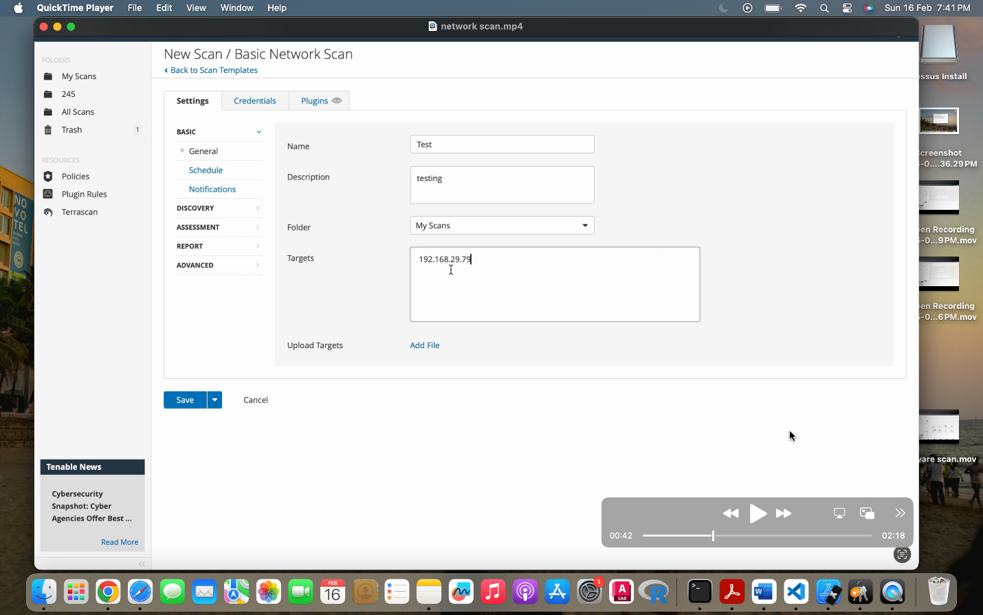

1.We Open Nessus (by Tenable) and create a new scan.

2.Then Select Basic Network Scan as the scan type.

3.Next, Enter the target IP address (192.168.29.74) to scan.

4.Configure additional settings such as Discovery, Assessment, Notifications, and Scheduling.

5. Save and start the scan.

**Step 2-**

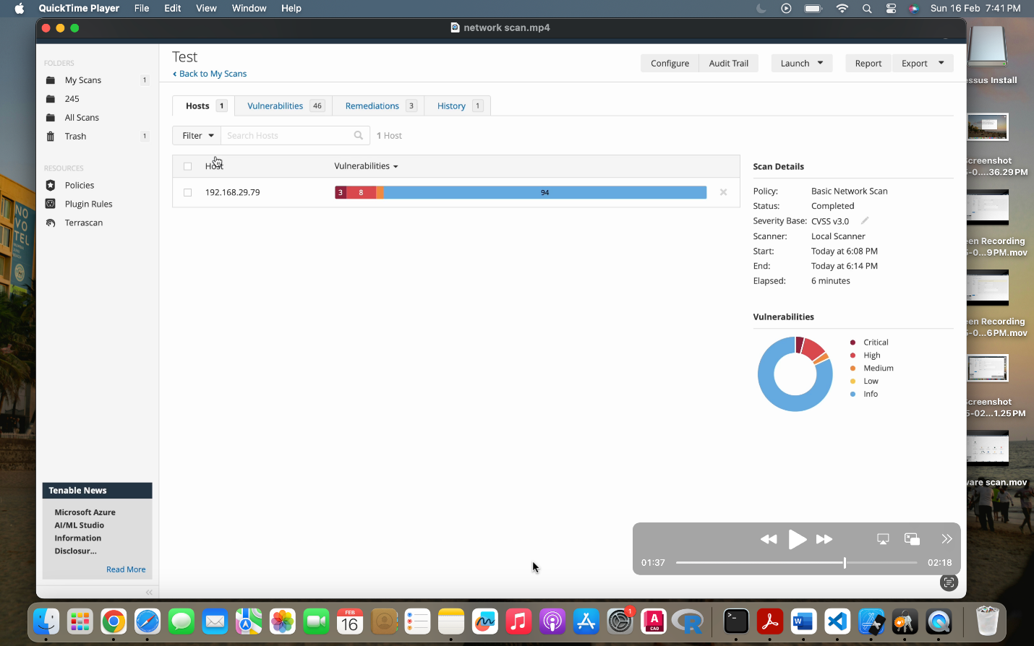

1.The scan completes successfully and displays a summary report.

* 1. host (192.168.29.74) was scanned.

3.46 vulnerabilities were detected, categorized into different severity levels:

* + Critical – High-risk vulnerabilities requiring immediate attention.
  + High – Security flaws that can be exploited.
  + Medium – Moderate risk vulnerabilities.
  + Low – Minor security risks.
  + Informational – System details that might help an attacker.

4.Scan duration: The scan started at 6:08 PM and finished at 6:14 PM (6 minutes).

**Step 3-**

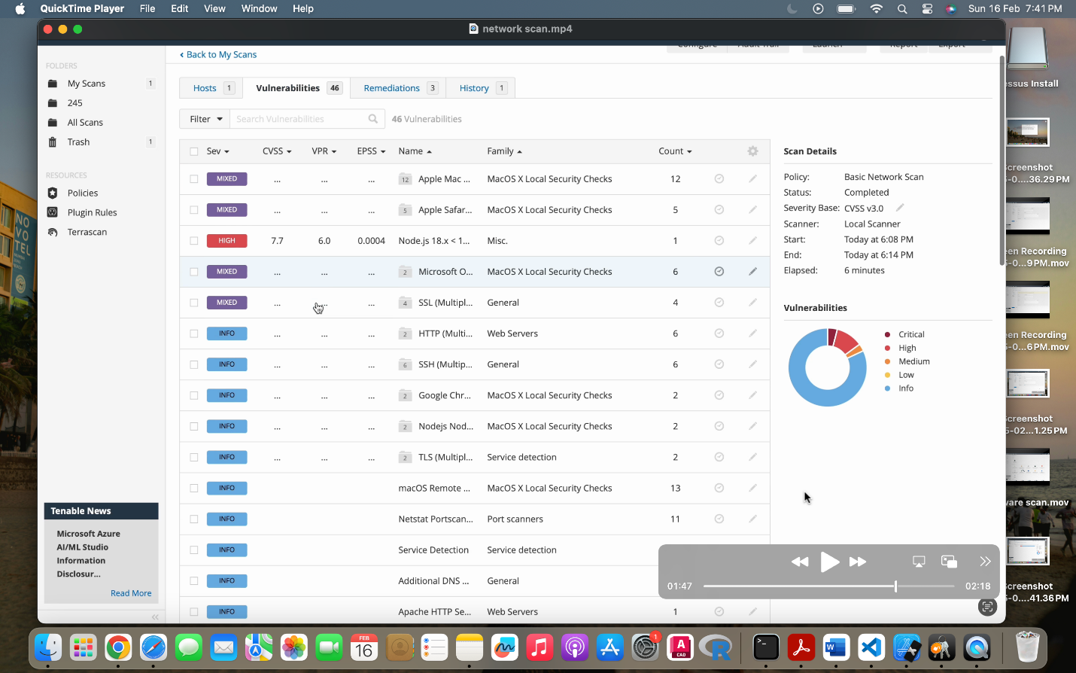

1.We identified vulnerabilities found in the scanned system.

2. The results show security issues related to:

* + macOS Local Security Checks (Apple Safari, macOS updates).
  + Node.js vulnerabilities.
  + Microsoft Office for Mac issues.

3.CVSS scores are displayed which indicate the severity of each vulnerability.

**Step 4-**

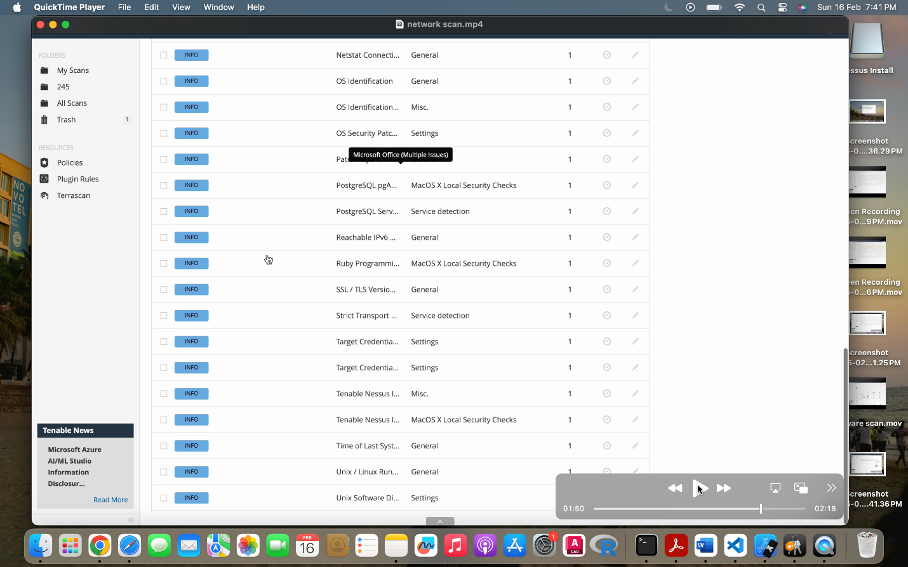

Then more vulnerabilities are listed, covering:

* SSL/TLS security risks (outdated encryption protocols).
* HTTP and SSH misconfigurations.
* Potential service exposure issues.

These vulnerabilities can be exploited for unauthorized access or data leakage.

**Step 5-**

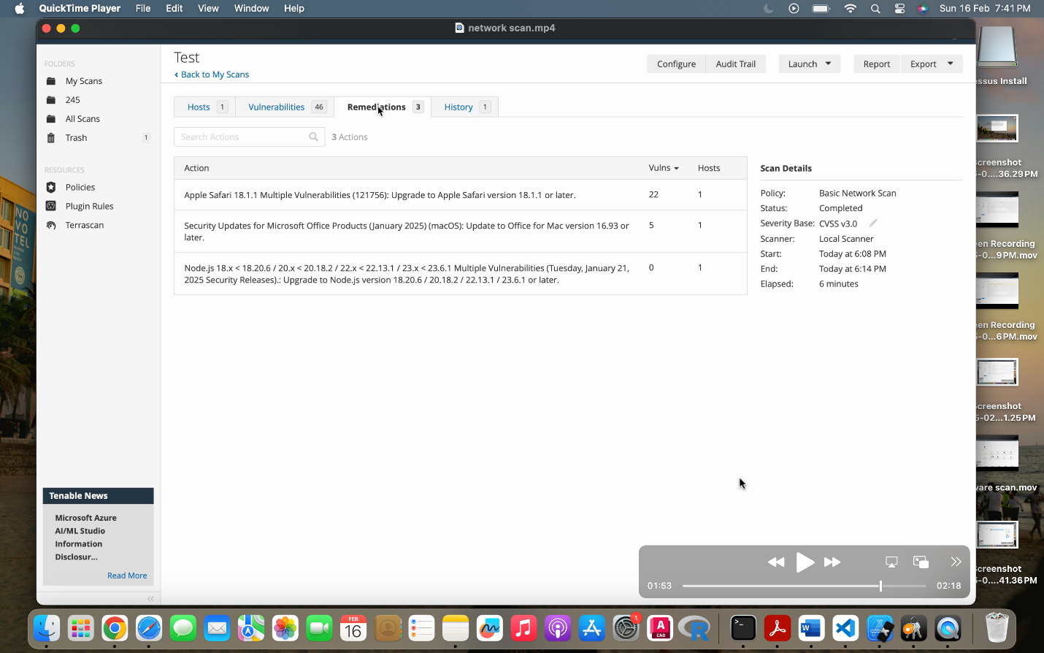

We find more specific vulnerabilities, including:

* PostgreSQL security flaws.
* Ruby programming issues.
* Operating system vulnerabilities.

Some findings involve service identification, which means attackers can determine which software versions are running on the system.

**2.Implementing a Web scan**

Pinging live website qualys.com :

Output: ip(162.159.152.21)

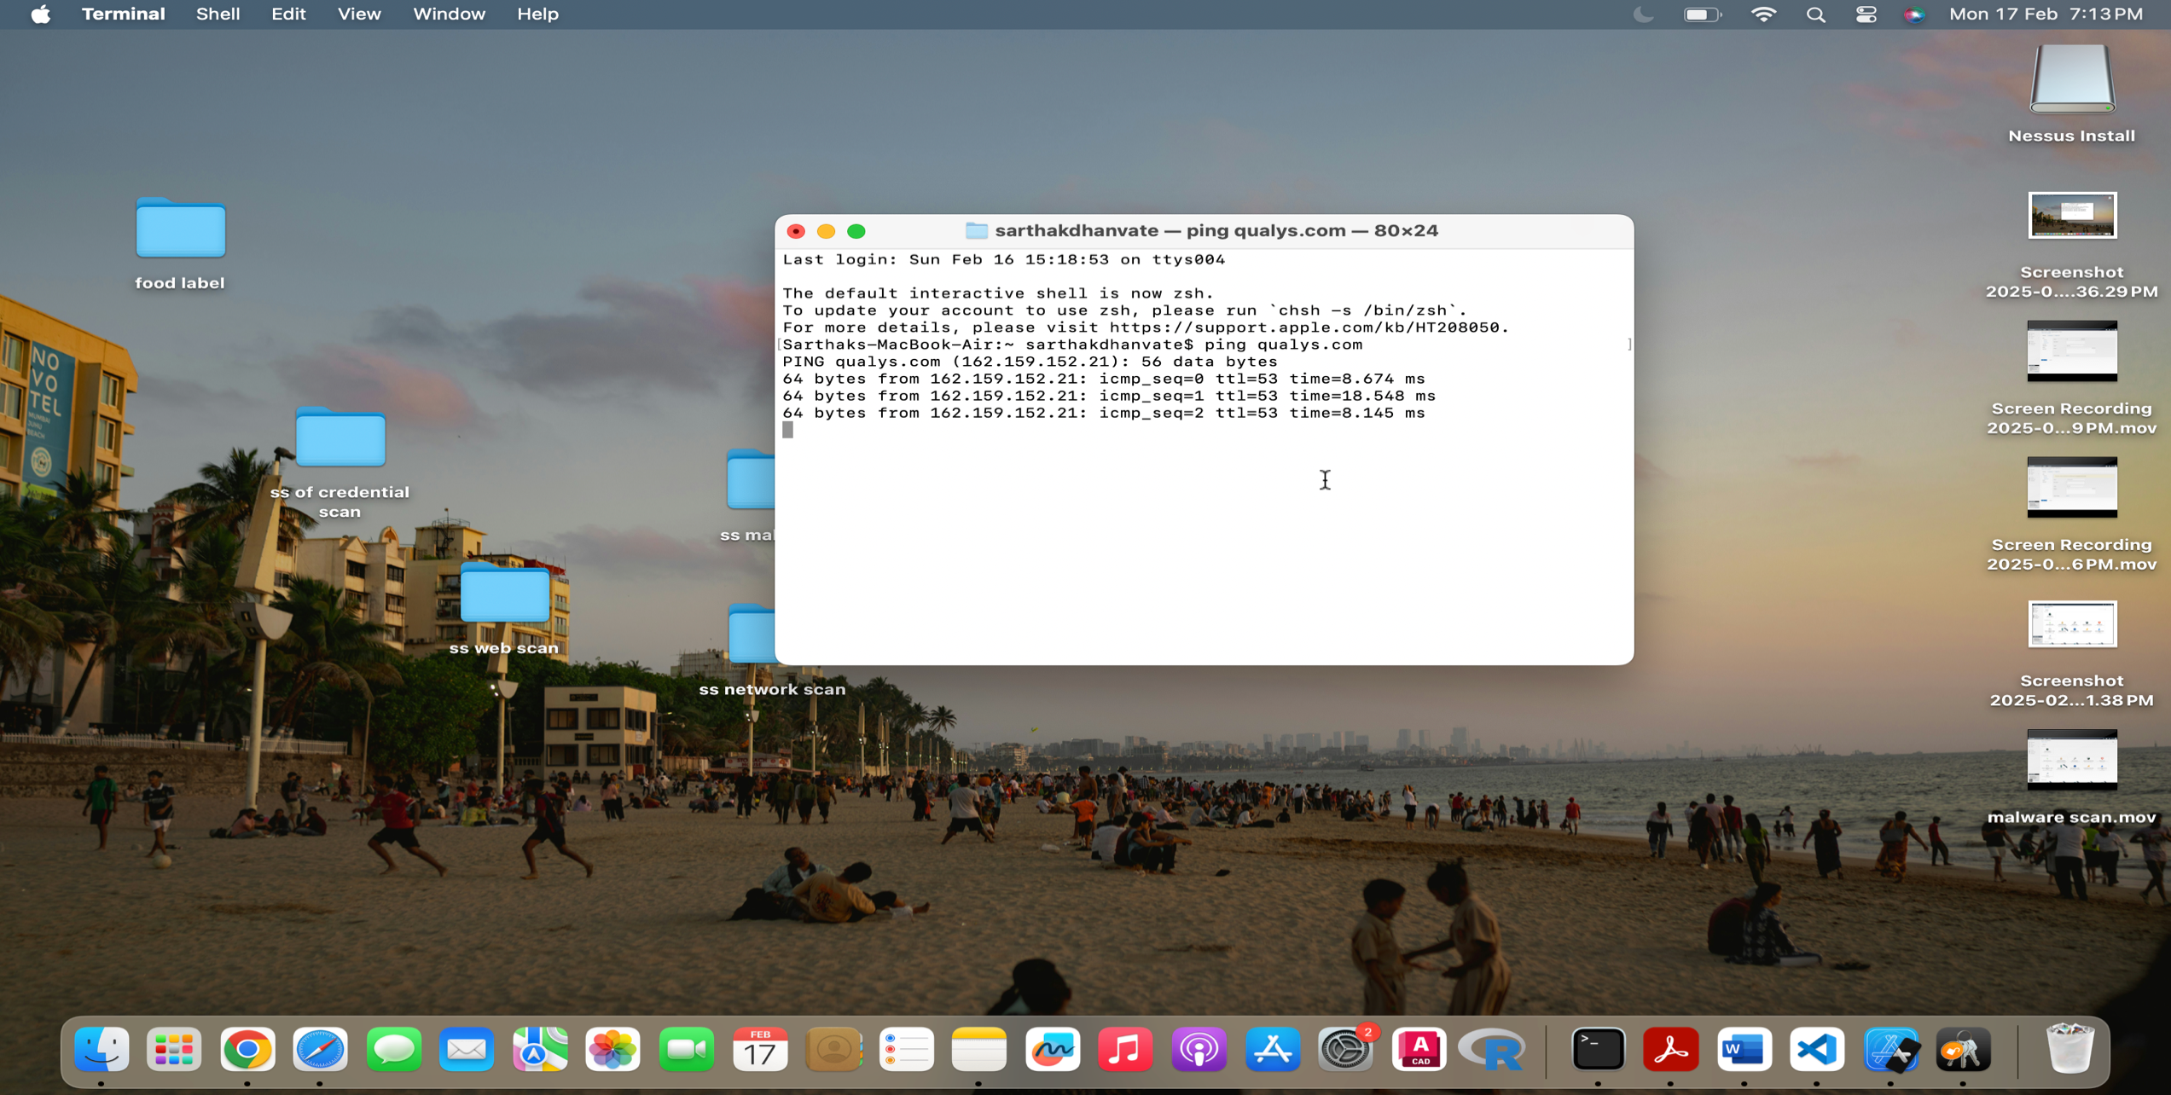

**Step 1-**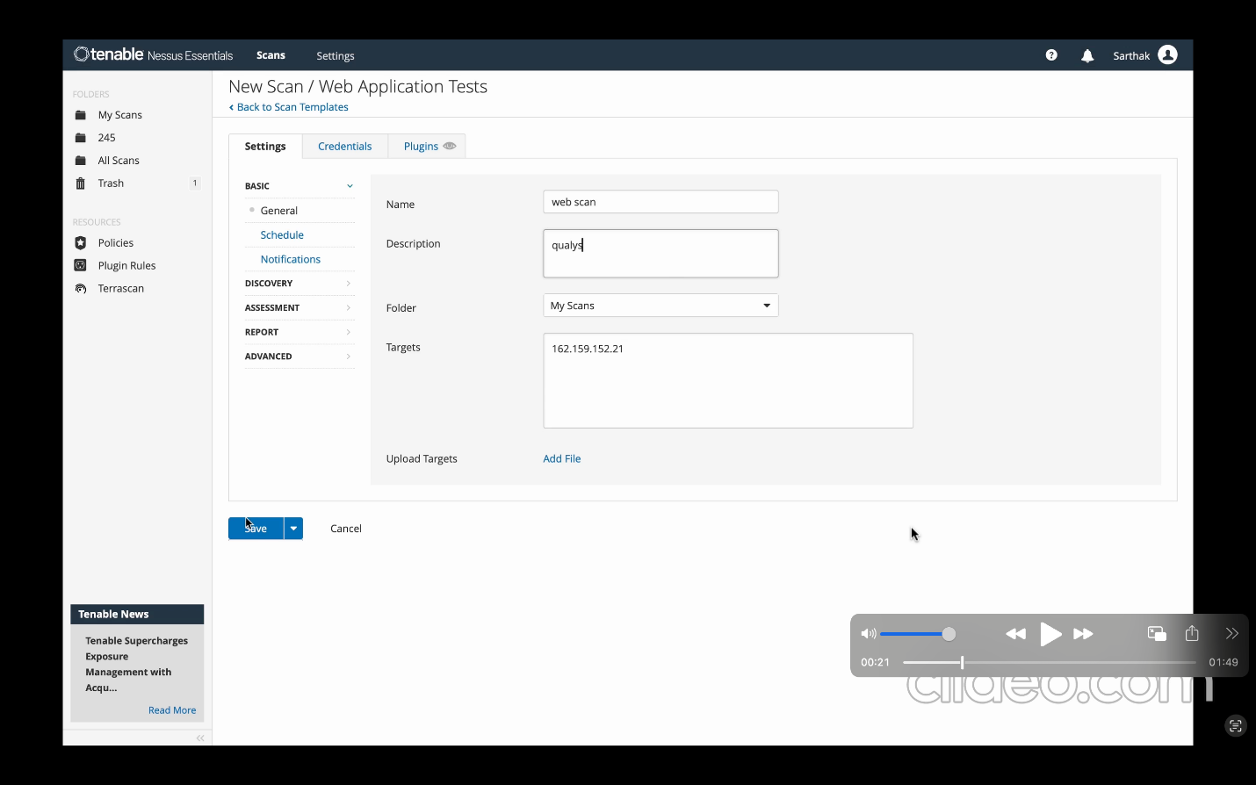

1. Opened Tenable Nessus Essentials

We access the "Scans" tab in Nessus Essentials.

1. Viewing Scan Results
   * The scan name is "web scan".
   * The only scanned host is 162.159.152.21.(Qualys.com)

**Step 2-**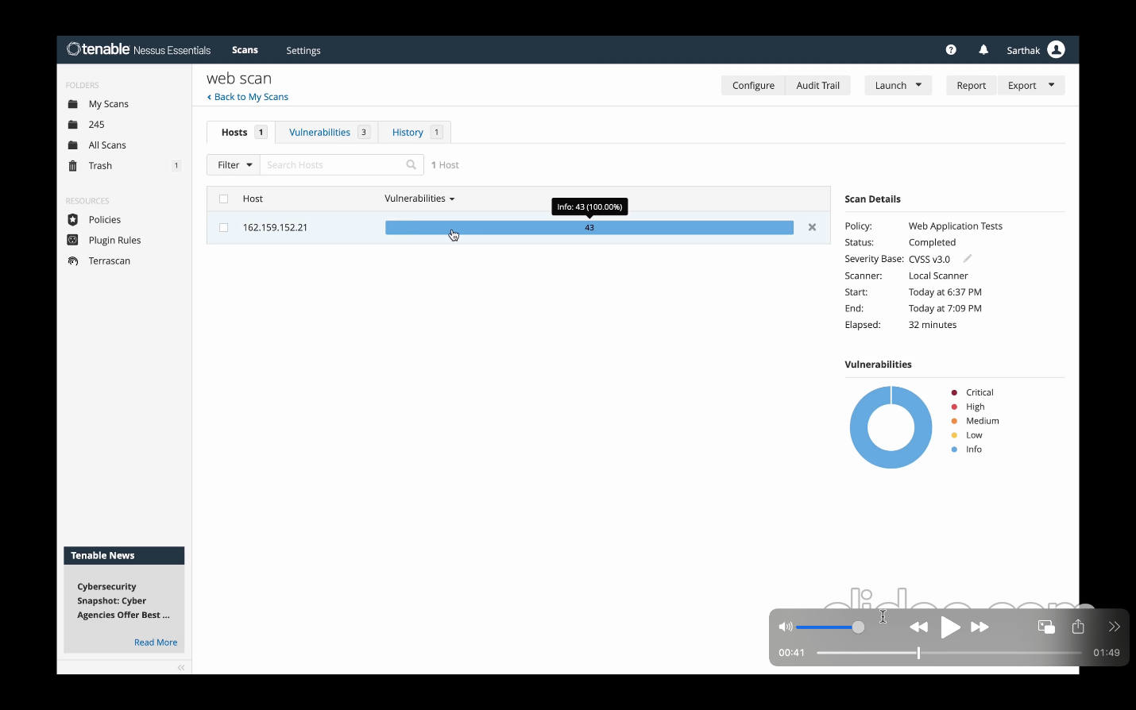

Checking Vulnerability Count

* 43 vulnerabilities were found on the host.
* All are informational (info), meaning no critical security risks were detected.

Reviewing Scan Details (Right Panel)

We observe that

* Scan Start Time: 6:37 PM
* Scan End Time: 7:09 PM
* Elapsed Time: 32 minutes

**Step 3-**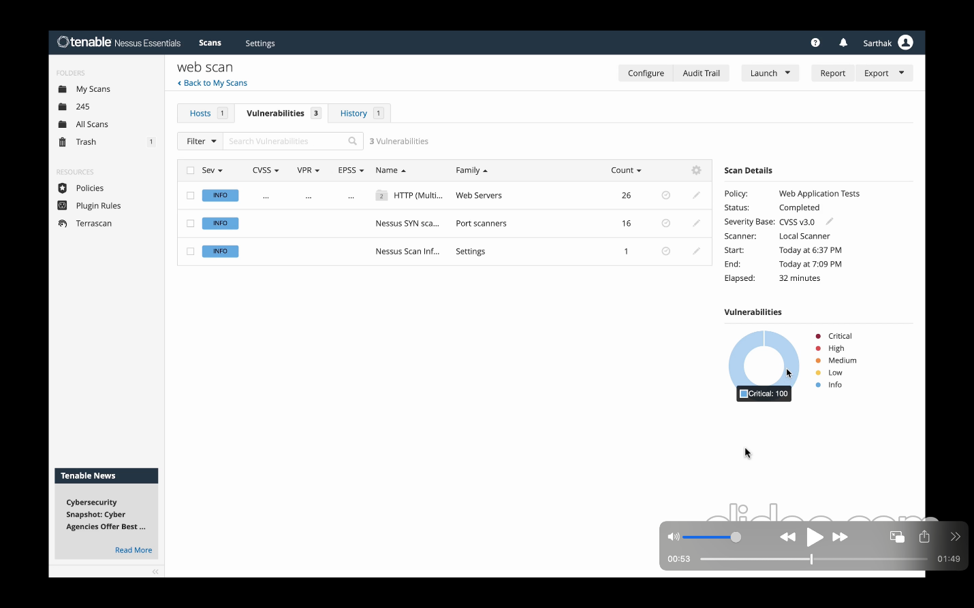

Opened the "Vulnerabilities" Tab

* We click on the "Vulnerabilities" tab to see detailed findings.

Reviewing the Detected Issues

* A list of vulnerabilities appears, categorized by severity (Critical, High, Medium, Low, Info).
* Since the previous screenshot showed 43 informational issues, all findings here are likely low risk or informational.

**Step 4-**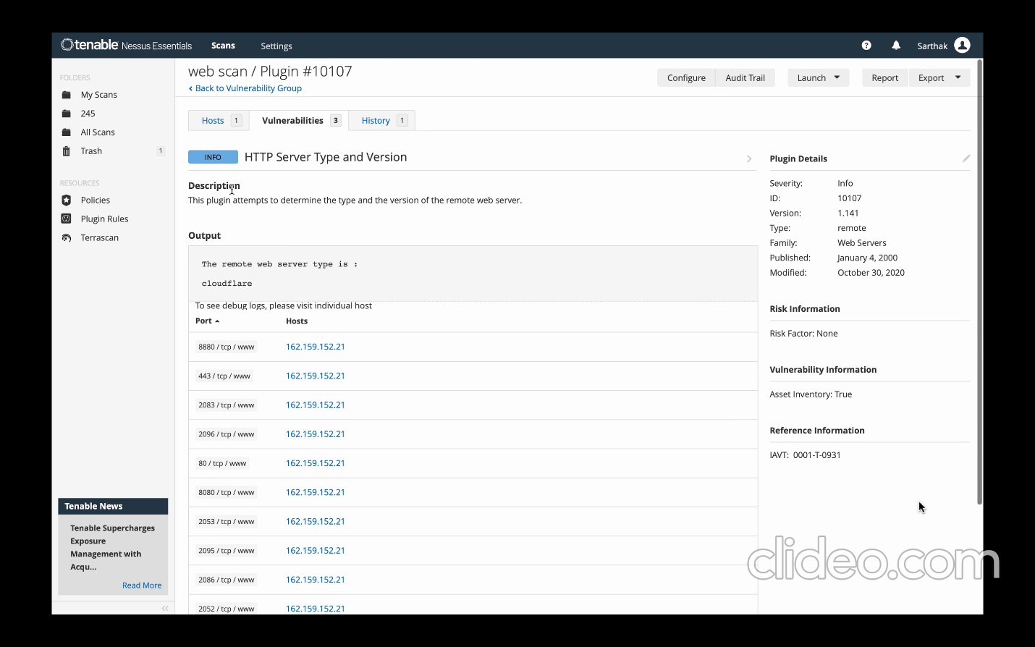

Clicked on a Specific Vulnerability

* We select a vulnerability from the list.

Then review the Vulnerability Details Page

* This page provides:
  + Vulnerability Name
  + CVSS Score (if applicable)
  + Affected URLs or Components
  + Risk Factor (e.g., Low, Info, Medium, High, Critical)

Nessus provides recommended remediation steps, such as:

* Updating software versions
* Fixing misconfigurations
* Applying security patches

**Step 5-**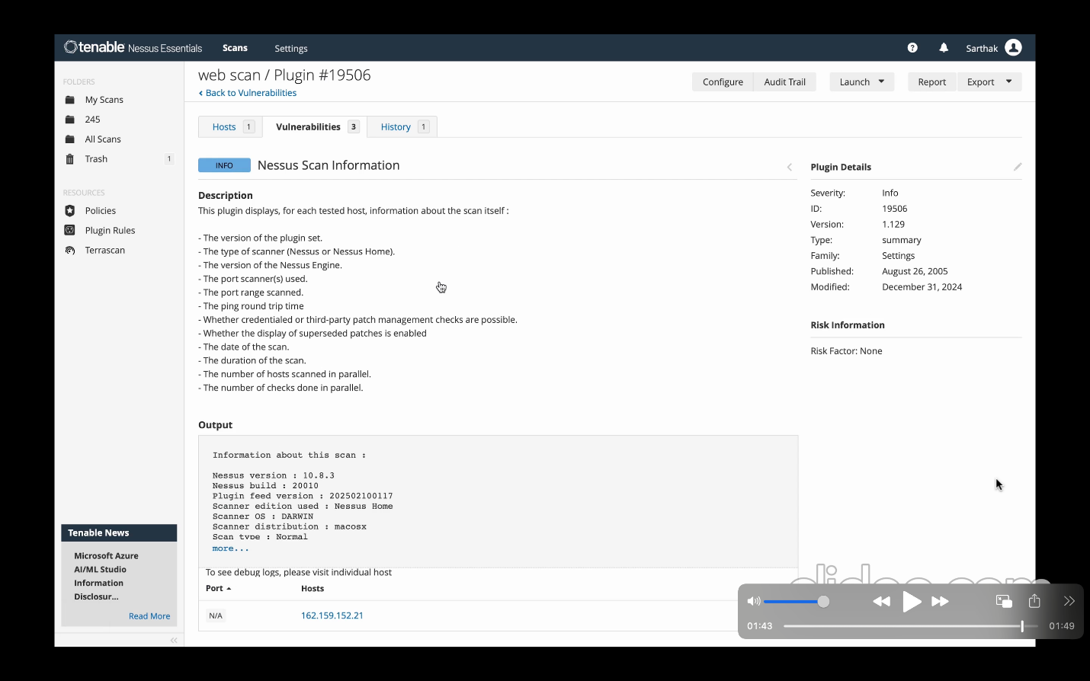

We find the description which explains the type of information gathered by the plugin, including:

Nessus plugin set version, Scanner type , Nessus Engine version, Port scanner details, Ping round-trip time, Date and duration of the scan etc.

Reviewing the Output Section

The scan results provide system details:

* + Nessus Version: 10.8.3
  + Nessus Build: 20010
  + Plugin Feed Version: 202502100117, etc

Checking the Scanned Host

* The target host 162.159.152.21 was scanned.
* No specific vulnerabilities are listed in this view.

**Step 6-**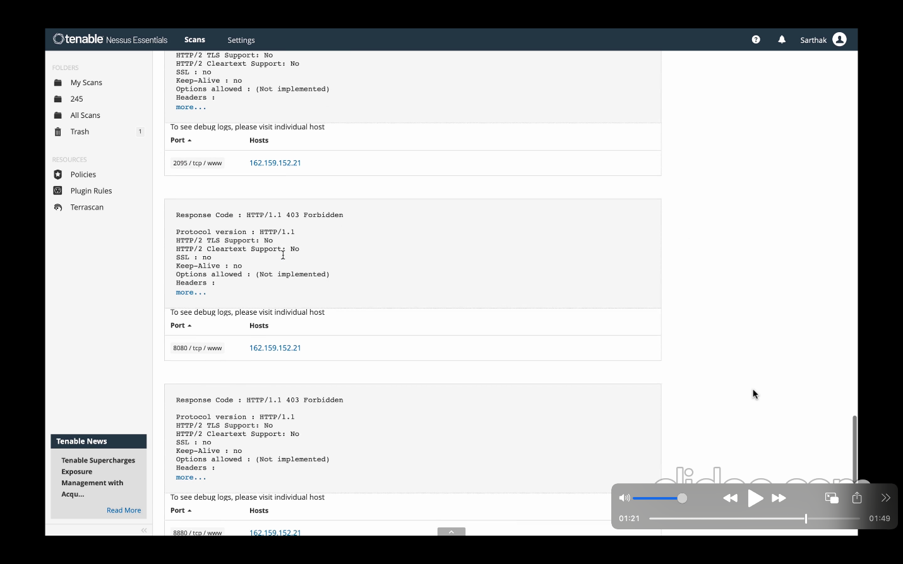

* The scan analyzed multiple ports on 162.159.152.21.
* The results list ports 2095, 8080, and 8880, each providing protocol details.
* We obtain details about Port 2095/tcp (Web Service) and Port 8080/tcp (Web Service - Forbidden Access)

**Similarly,**

1. **Implementing a Malware scan shows following output:**

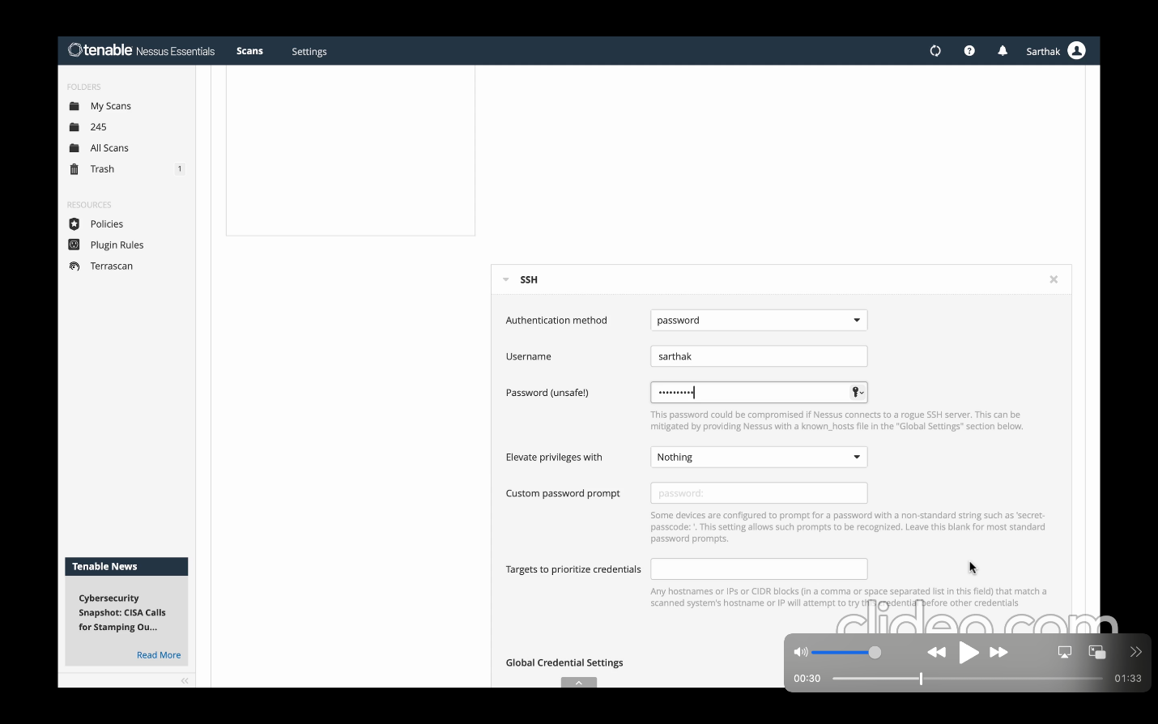

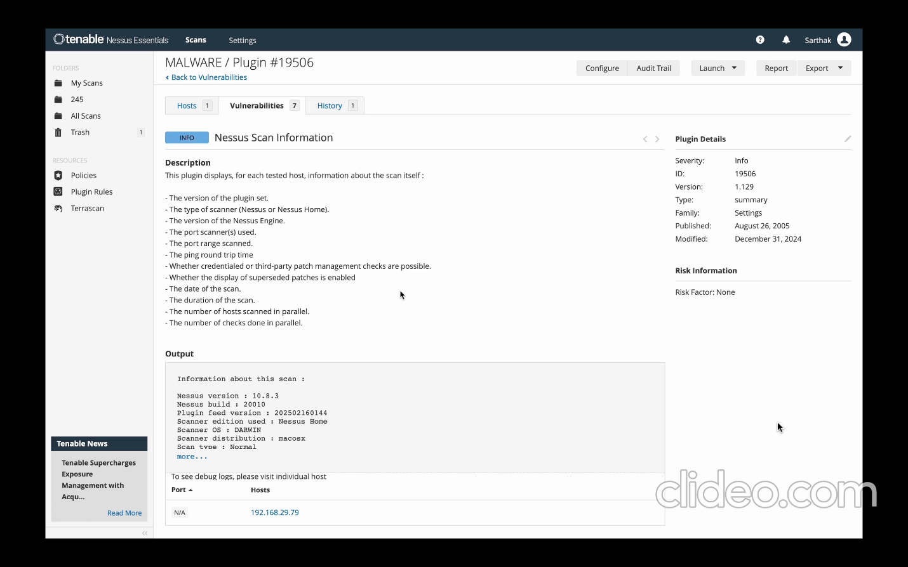

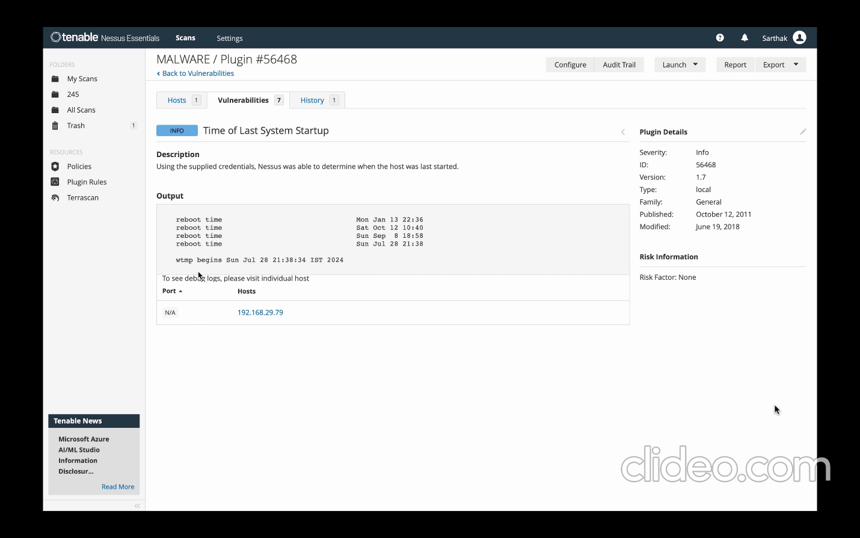

The malware scan detects malicious files, backdoors, and unauthorized system changes.

We ran the malware scan on a suspected system.

Nessus searched for malware signatures, suspicious files, and system modifications.

It flagged potential threats and recommended remediation actions.

This scan is essential for identifying threats that may bypass traditional antivirus solutions.

**4.Implementing a Credential scan provides the following output:**

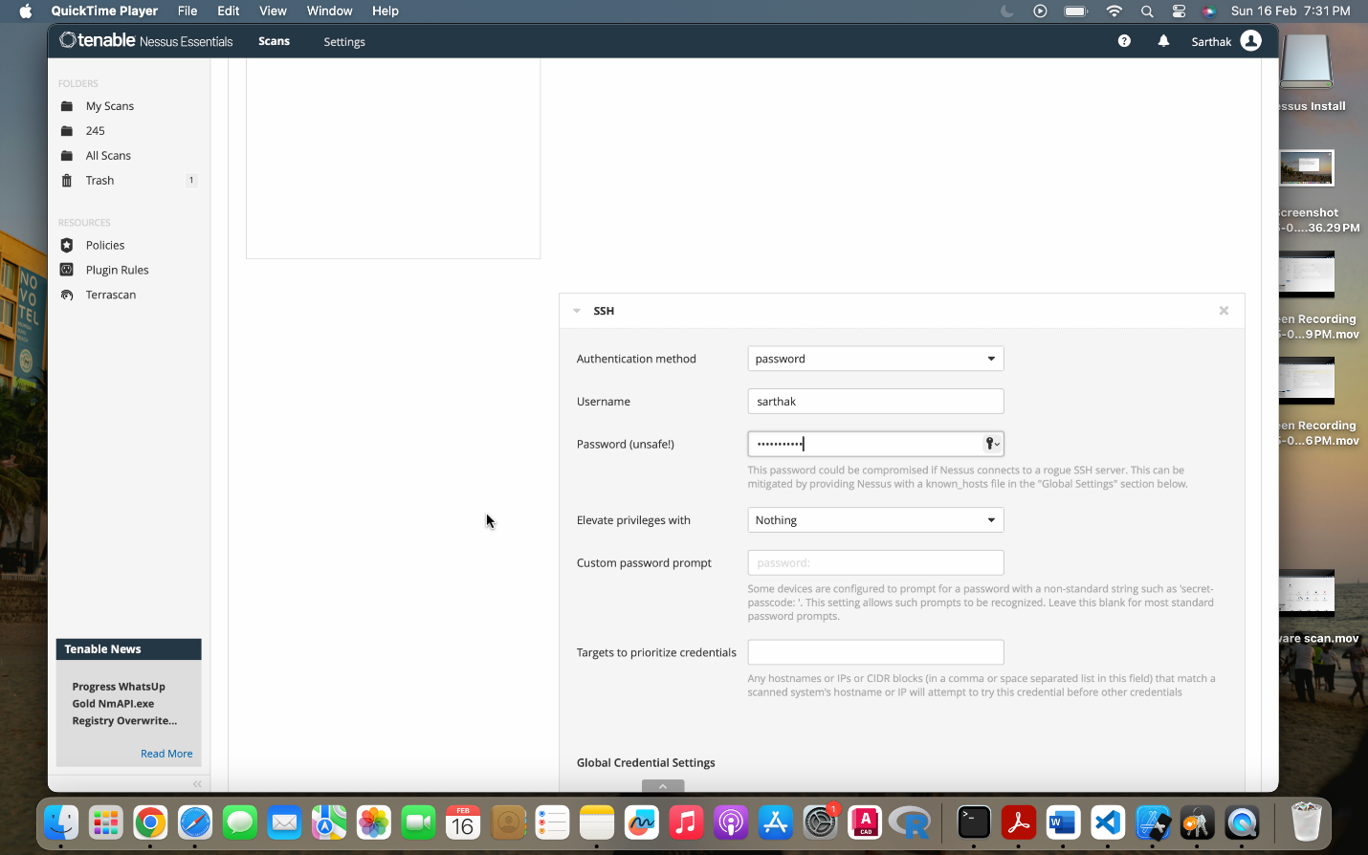

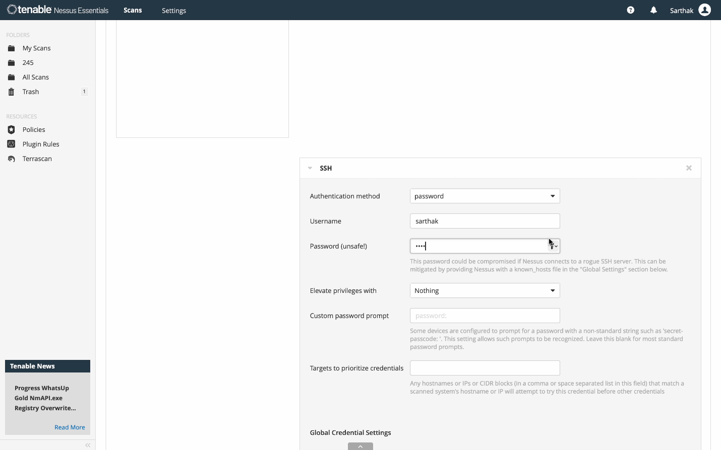

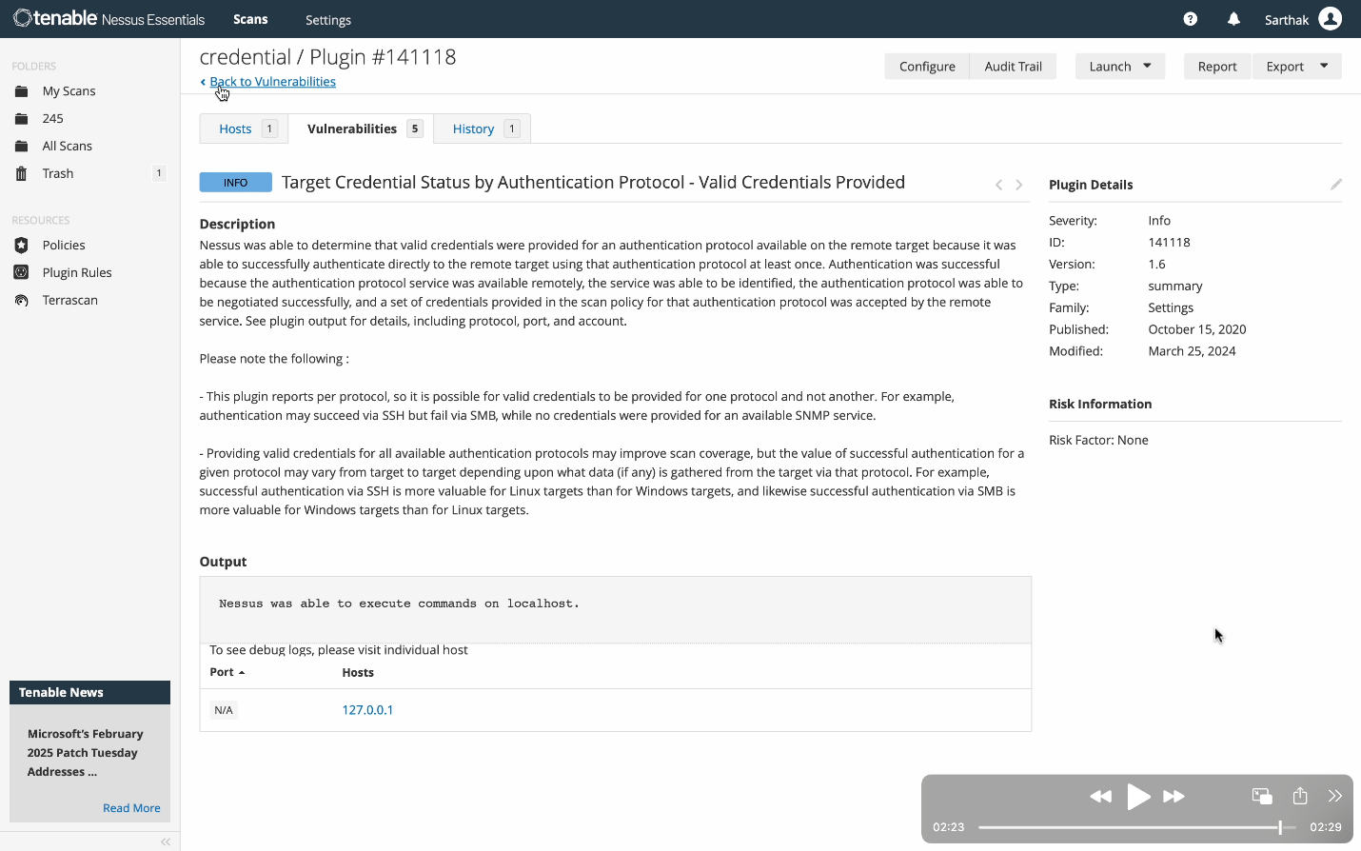

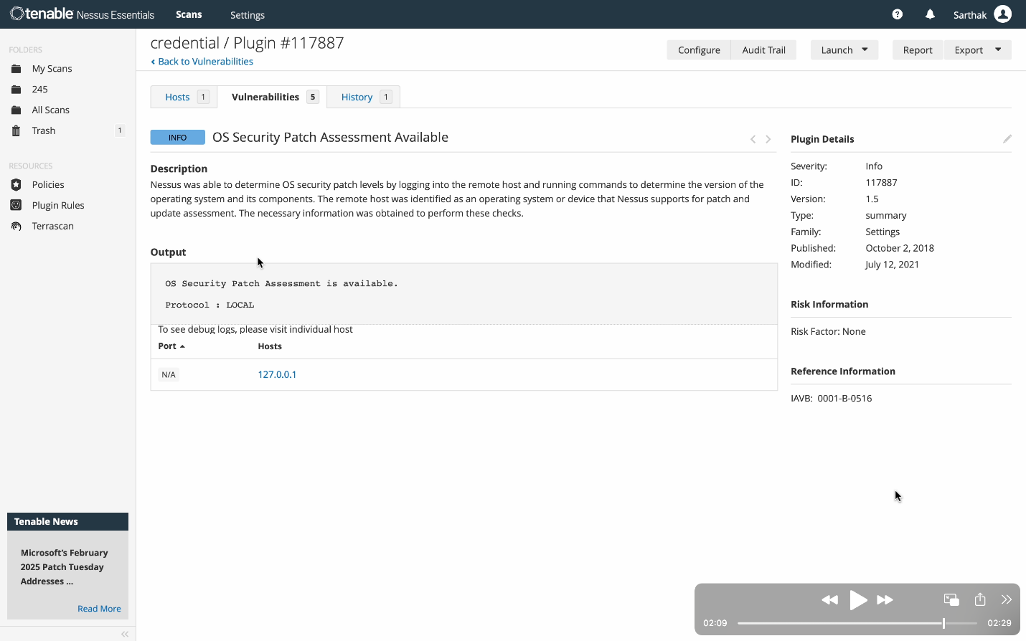

A credentialed scan provides deeper insights by logging into the system and scanning from an internal perspective.

We provided administrator credentials to Nessus for deeper analysis.

**This allowed Nessus to check for:**

* Unpatched vulnerabilities
* Weak passwords
* Misconfigured system settings

**The results highlighted security gaps that non-credentialed scans wouldn’t have detected.**

**This scan is crucial for assessing internal threats that could be exploited if an attacker gains access to a system**

**Conclusion**

Nessus is a powerful and reliable vulnerability assessment tool that helps organizations identify and mitigate security risks proactively. With comprehensive scanning, compliance auditing, and automation, it enhances security efficiency across various platforms. Its scalability, risk-based prioritization, and seamless integration make it suitable for businesses of all sizes. Backed by continuous updates and an active user community, Nessus remains at the forefront of cybersecurity. Ultimately, it enables organizations to achieve compliance, protect critical assets, and strengthen their security posture.